Agan Lev

Community Conversation – The Future for Cornish.

Acorn Theatre. Sun 26th February 11-3pm

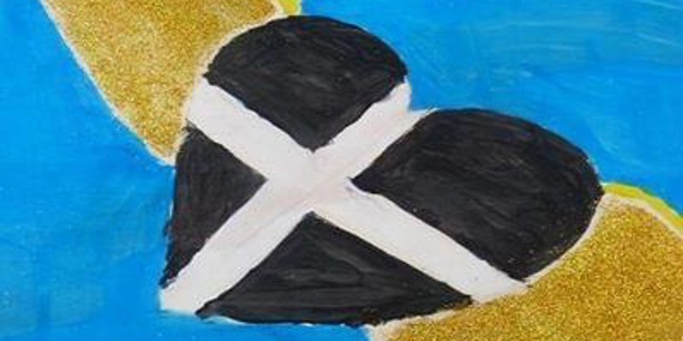
A one-day seminar arranged by the Cornish Language voluntary groups, working in partnership, to discuss the community’s view on the way forward for Cornish.
Language speakers, learners, supporters and activists are encouraged to take part in a one-off opportunity to come together to form an action plan for the language community.

Programme: The programme will include a presentation on where we are, followed by facilitated group discussions on the strengths, weaknesses, threats and opportunities. A networking lunch will be followed by feedback on the morning session and break-out groups on the topics raised. A final session will bring the threads together and look at the way forward for the language community.
There is no fee for the day. Coffee, tea and a pasty lunch will be provided. In order to help with this we would be grateful if you would book in advance so that we know numbers.

Bookings at: https://www.eventbrite.co.uk/e/agan-lev-tickets-31229823242
Or by email: jeneferl@hotmail.co.uk or ring 07718763566 to confirm

